**NHS Wi-Fi**

The following steps will guide you through how to gain access to the NHS Wi-Fi that is now available at GP Practices.

1. **Connecting to NHS Wi-Fi**

From your device connect to the Wi-Fi named ‘**NHS Wi-Fi’**. (Device specific instructions are given at the end of these instructions).

**Note: Please note it is not the responsibility of the practice or IT provider to configure or fix any issues with your device in order to connect to the NHS Wi-Fi.**

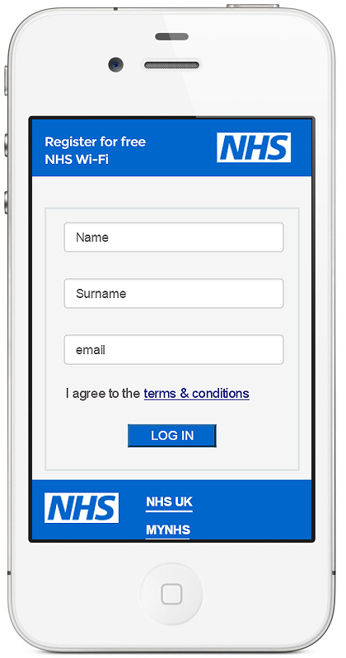

1. **NHS Wi-Fi Registration and Enrolment**

Once you have successfully connected to the NHS Wi-Fi a registration screen will pop up as shown below. (Android phones may require you to open the web browser manually)

* Read the terms & conditions
* Fill in your First name, Surname and Email address
* Tap the button

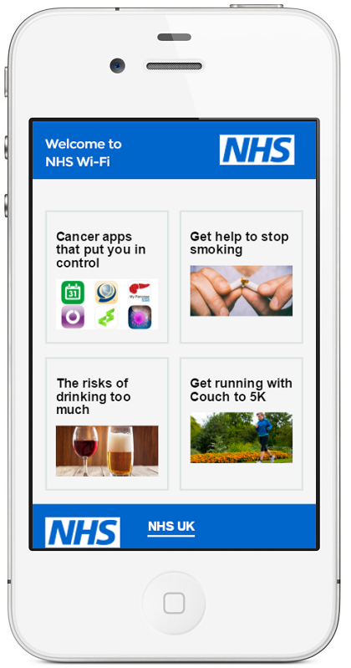

1. **Post-Authentication Screen**

Once you have successfully joined NHS Wi-Fi you will be taken to the post-authentication screen shown below.

The Post-Authentication screen contains advice and guidance such as ‘Get help to stop smoking’.

There are also a number of apps you can download.

The content is hosted and maintained by NHS Digital.

From this point you can open a separate web browser to surf the internet, use apps such as Facebook etc.

**Summary**

* Connect to NHS Wi-Fi.
* Read terms & conditions, then complete the registration and enrolment process.
* If you wish navigate away from the post-authentication screen then open a separate web page.

**Device specific instructions**

**iPhone**

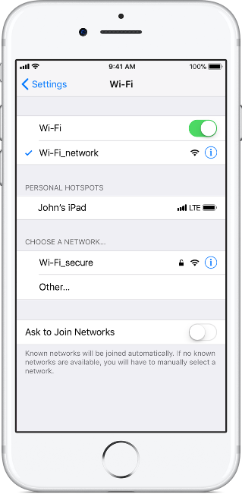

* From your Home screen, go to Settings > Wi-Fi.
* Turn on Wi-Fi.  
  Your device will automatically search for available Wi-Fi networks.
* Tap the name of the Wi-Fi network that you want to join.

After you join the network, you'll see  Checkmarknext to the network and Wi-Fi connected in the upper-left corner of your display.

* The registration and enrolment screen will ‘pop up’.

**Note: there is no password required.**

**Android device**

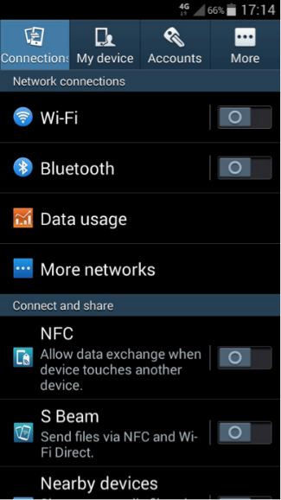

* Swipe down from the top of your phone and tap on the Wi-Fi button. Alternatively, from the Home page, go to Apps > Settings and tap on the button next to Wi-Fi so that it turns green with a line down the middle.
* Tap on ‘Wi-Fi’ to see the list of available networks. It may take a moment for all available networks to show up. You can force your device to check for networks by tapping on ‘Scan’.
* Select the network you would like to use. If this is an open Wi-Fi connection, you will automatically connect without any further action needed, but be aware that this will not be secure. **Note: there is no password required.**
* Open a web browser and type then search for something.

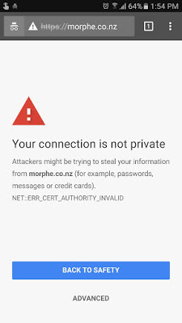

* You may be presented with a screen stating ‘your connection is not private. Click the ‘advanced’ button.

[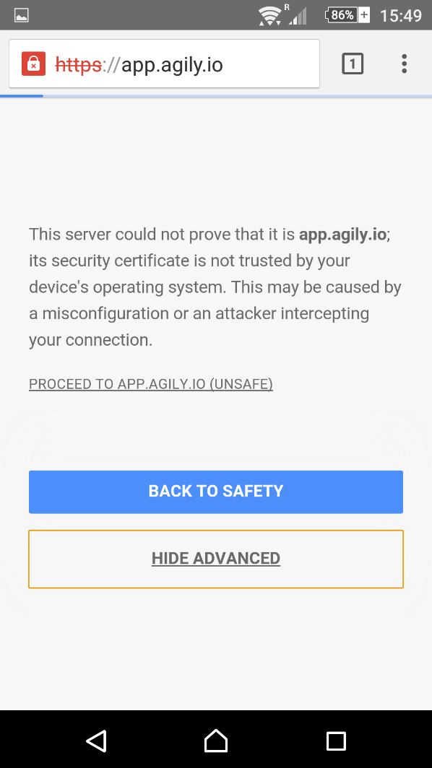](http://www.google.co.uk/url?sa=i&rct=j&q=&esrc=s&source=images&cd=&cad=rja&uact=8&ved=0ahUKEwiw29Kanb3YAhVBkBQKHY3ODXAQjRwIBw&url=http://www.agily.io/your-connection-is-not-private-security-message-android/&psig=AOvVaw1kmNmdVuhWrFTqWwN74O9d&ust=1515118163952552)

* Another screen will pop up then press the ‘proceed to’ link. You should then be redirected to the registration and enrolment screen.

**Windows Laptop**

* Select the **Network** [Image result for wireless icon windows 10](https://www.google.co.uk/url?sa=i&rct=j&q=&esrc=s&source=images&cd=&cad=rja&uact=8&ved=0ahUKEwimjJeTq93XAhWR56QKHcJkByUQjRwIBw&url=https://www.tenforums.com/tutorials/3507-delete-wireless-network-profile-windows-10-a.html&psig=AOvVaw1es8_InrqIBYd1M3owSTM8&ust=1511823355691036) or [Image result for wireless icon windows 7](http://www.google.co.uk/url?sa=i&rct=j&q=&esrc=s&source=images&cd=&cad=rja&uact=8&ved=0ahUKEwik4PWcq93XAhWSp6QKHSaIAlIQjRwIBw&url=http://www.intowindows.com/how-to-connect-windows-7-to-a-wireless-network/&psig=AOvVaw0PPoFDHE3fmw--aA8aySOf&ust=1511823407807083) icon in the notification area at the bottom right of your task bar
* In the list of networks, choose the network named ‘NHS Wi-Fi’ and then select **Connect**.
* Open up your web browser to complete the registration process.